1. Word Edit functionality-> If word contents are changed then and then only Popup message “word updated successfully”. (P1)

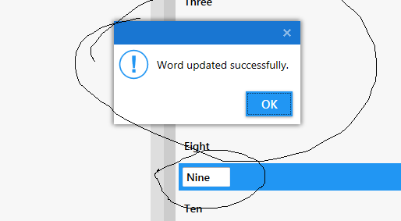

1. Message box focus lost in all operations. (This is for all of us. Please make sure that message popup focus is not losing). (P1)
2. Help button shows the empty screen. (P3)
3. Confirm the Add child/ Delete Child busy indicator text. Currently it is “Please wait…” make sure that text content followed by “…”, I think this should be as “Please wait.” (P2 Confirm it from Sir/Madam)
4. Add horizontal scrollbar in Child list names in dropdown as well as in Child Panels For long text it get cut. (P1)

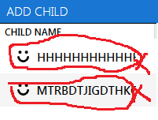 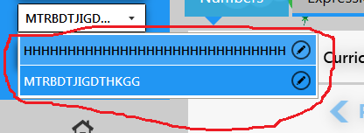

1. Image in play number goes outside of the canvas. For Numbers in the range of 1-5 this problem occurs. This happens for most of the numbers. (P1)



1. Application plays the lesson in the range of the 50-80 with repetition counter 1 for more 3 minutes. I think number is repetition more no 1 (P1)
2. Add new child with empty data then click on export it shows me save dialog box if I save the file it shows me message Corrupted file cannot be imported but I am exporting lesson then why import message is there? (P1 but hard to reproduce so change the message when exporting)

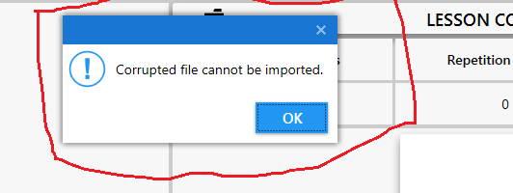

1. On Click on ok in above message in Bug no 8 it shows me message File exported successfully. (P1 but hard to reproduce)

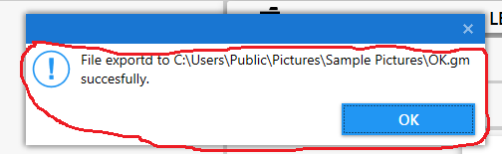

1. First of all check where is there any lesson in selected day if yes then popup save dialog if no then give message that lesson is not present. (Confirm this message from Sir/Madam) (P1)
2. When I select the Play all radio button in Numbers tab and switch tab to expressions then it shows me selected radio button as Play all but if change it to Plat selected it changes in both tab (P1).
3. If I play the entire lesson by selecting Play all radio button then it does not shows me lesson number which is playing. It continues play without any interruption in play. (P1)
4. On import it does not add the show that importing is in progress. (P2)
5. On changing child from the child dropdown list the curriculum is not changing and the day list is not updating because of that lesson is not displaying, but if change the day then it shows me lessons. I think when child change event occurs ui is not refreshing pls check it. (P1)

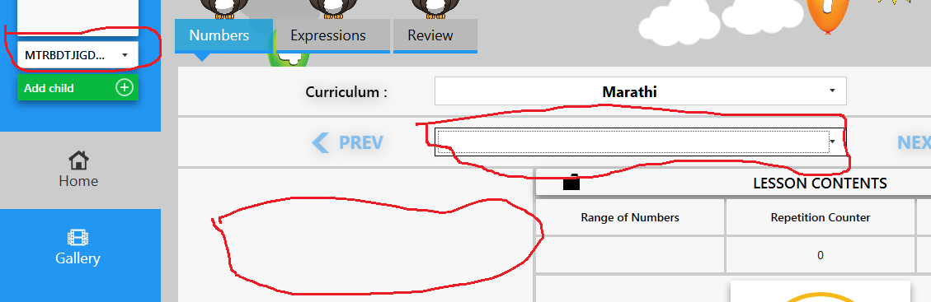

1. Value cannot be null exception in Number Lesson Edit custom tab on delete. (P1)
2. In Number Lesson Edit custom on cancel button it popup message 2 times for Do you want to save changes (P1)
3. On Click on Save button in Number Lesson Edit window it gives popup as Changes Saved successfully but I haven’t change anything in it. Just open the window and click on the Save button. (P1)
4. Click multiple times on save button gives popup changes save successfully. (P1)
5. In Number Edit window if 1st number is 0 then it does not play the lesson. (P1)
6. Repetition counter is not updating even though I have updated it. This happens in lesson edit window. On save updated counter is displayed but if I play the lesson then it doesn’t make changes and display the previous changes as it is. (P1)
7. On deleting lesson from the day it shows lessons center aligned. (P1)



1. Number Edit window and Expression Edit window in Sound and Display tab Sound Settings Dock panels are different. (P1)
2. If user change the Expression selection range then in all expressions (+,-\*,/) value get change. If user has changed the + operation range then it should not be applicable to other operations. (P1)
3. Not able to play the lesson in expressions tab (both for + and custom expressions not check with others) (P1)
4. What about the Volume Slider. (P2)
5. When play a lesson shortcut key for Add child, download, help etc. are working (P1)
6. On Window drag it shows window in small size. (P1)
7. In Window Lesson list and Lesson contents are not properly aligned. List part is slightly above the Lesson contents
8. Add Default Icon in Application.
9. Add in seconds text in front of the Play speed in both edit windows
10. If user has select range 91-95 and max value of solution is 95 then on click on Paly it Is not working.
11. Check word is not empty on enter key or save button.